• The secondary and backscattered electrons are used for imaging while the X-rays give characteristic chemical information of the emitting atoms.
Factors that affect SE emission
3. Atomic number (Z)
• More SE2 are created with increasing Z
• The Z-dependence is more pronounced at lower beam energies
4. The local curvature of the surface
(the most important factor)
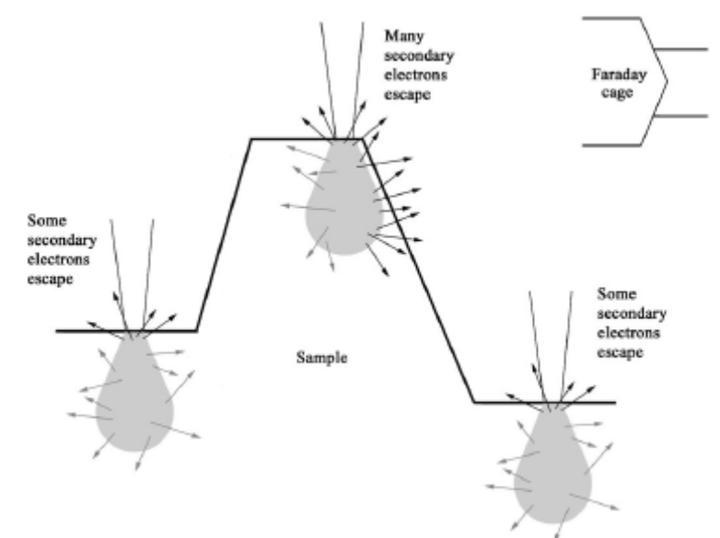

Backscattered electrons (BSE)
• A fraction of the incident electrons is retarded by the electro-magnetic field of the nucleus and if the scattering angle is greater than 180 ° the electron can escape from the surface
• Back scattered electrons(BSE) consist of high-energy electrons originating in the electron beam, that are reflected or back-scattered out of the specimen interaction volume by elastic scattering interactions with specimen atoms.
• Since heavy elements (high atomic number) backscatter electrons more strongly than light elements (low atomic number), and thus appear brighter in the image.
• High energy electrons (elastic scattering)
• Fewer BSE than SE

